**Stanford CS229 Machine Learning Problem Set #1 Coding Problems**

## **1. Linear Classifiers (Logistic Regression and GDA)**

### 1-b. Logistic Regression and separating hyperplane for Dataset 1

### 1-e. GDA model and separating hyperplane for Dataset 1

### 1-f. Compare results of Logistic Regression and GDA model on Dataset 1

The separating boundary for Logistic Regression seems more reasonable than for GDA.

For Dataset 1, Accuracy (Logistic Regression) = 0.83 and Accuracy (GDA) = 0.81, so the accuracy for Logistic Regression is also higher than GDA.

### 1-g. Logistic Regression and GDA on Dataset 2

Logistic Regression separating hyperplane on Dataset 2.

GDA model separating hyperplane on Dataset 2

Results of Logistic Regression and GDA model on Dataset 2 comparison:

For Dataset 2, Accuracy (Logistic Regression) = 0.86 and Accuracy (GDA) = 0.86, so GDA does not perform worse than Logistic Regression.

For Dataset 1, X might not follow Gaussian Distribution, causing GDA to perform worse than Logistic Regression, which is a more robust model. For Dataset 2, X follows Gaussian Distribution, so it performs as good as Logistic Regression.

### 1-h. Possible transformation on $x_{2}$

A possible transformation is to set $x_{2}≔logx_{2}$, which makes $x_{2}$ follow Gaussian Distribution.

## **2. Incomplete, Positive-Only Labels**

### 2-a. A plot to visualize the test set with $x_{1}$ on the horizontal axis and $x_{2}$ on the vertical axis. Use different symbols for examples $x^{(i)}$ with true labels $t^{(i)}=1$ than those with $t^{(i)}=0$. And plot the decision boundary obtained by Logistic Regression trained with t-labels.

### 2-b. A plot to visualize the test set with $x_{1}$ on the horizontal axis and on the vertical axis. Use different symbols for examples $x^{(i)}$ with true labels $t^{(i)}=1$ than those with $t^{(i)}=0$. And plot the decision boundary obtained Logistic Regression trained with $y^{(i)}$ and predicted naively with the parameter obtained.

### 2-f. A plot to visualize the test set with $x_{1}$ on the horizontal axis and $x_{2}$ on the vertical axis. Use different symbols for examples $x^{(i)}$ with true labels $t^{(i)}=1$ than those with $t^{(i)}=0$. Estimate an $α=\frac{1}{\left|V_{+}\right|}Σ_{x^{\left(i\right)}ϵV_{+}}h(x^{\left(i\right)})$. And predict the validation sample with Logistic Regression and scaled by this $α$. Plot the decision boundary obtained the adjusted Logistic Regression.

## **3. Poisson Regression**

### 3-d. A scatter plot between the true counts vs predicted counts on the validation set.

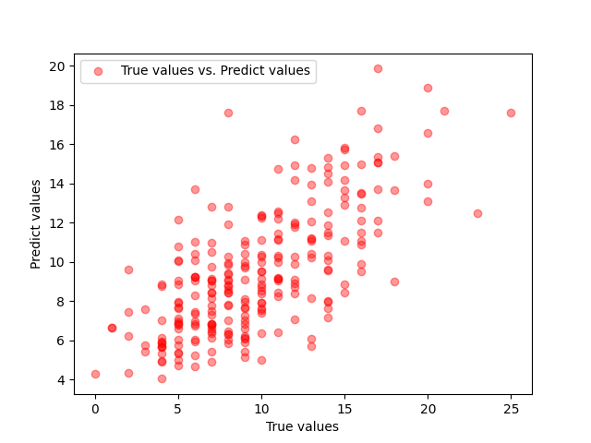

## **5. Linear regression: linear in what?**

### 5-b. Degree-3 polynomial regression

A scatter plot of the training data, and the learnt hypothesis as a smooth curve over it

### 5-c. Degree-k polynomial regression

A scatter plot of the training data, and different learnt hypothesis curves for each value of k. k = 1, 2, 3, 5, 10, 20. In 5-c, .

Higher degree of polynomials makes the model fit the data better, however it is also more numerically unstable.

### 5-d. Degree-k polynomial with sin(x) regression

A scatter plot of the training data, and different learnt hypothesis curves for each value of k. k = 1, 2, 3, 5, 10, 20. In 5-c, .

Higher degree of polynomials with an additional sin(x) makes the model fit the data even better, however it still exhibits the same numerically instability.

### 5-e. A smaller dataset.

Smaller dataset with just degree-k polynomial.

Smaller dataset with just degree-k and sin(x) polynomial.

With a much smaller dataset, although models with higher degree polynomials passes through all points, it still seems like a poor fit. Numerical instability remains a major problem regardless of whether sin(x) exists or not.